Module 11

UFOs

Project Overview

I used JavaScript and HTML to modify the code in  index.html file to create more table filters. In addition to the date filter, I add filters for the city, state, country, and shape, as shown in the following image.

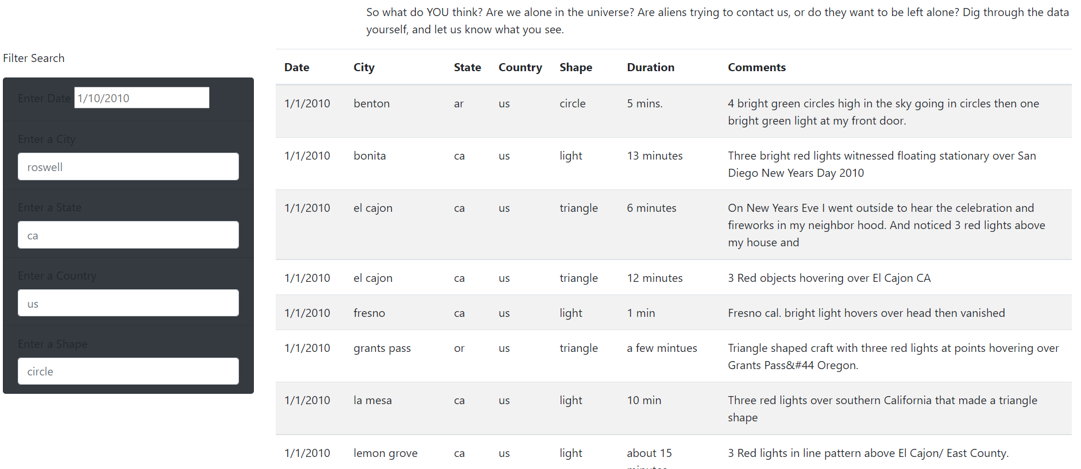

**Results**

The webpage created is for ufo sighting data with a filter table that allows users to easily filter on various criteria such as date, city, state, and shape of the UFO sighting. A global unfiltered view can be seen below.

The displayed results are dynamically filtered as you update the form field entries. There is no needed Submit or Refresh button as the tables update in real time

**Summary**

This current webpage has a main advantage in that users can search upon multiple criteria at one time and there is no submit button. Instead, there are also some drawbacks. The main draw backs all have to do with the fact that the search options don't provide much idea as to available options to search on. The current fields are all text boxes and these can allow for a lot of user errors or just simply misinterpretation. This makes the data analysis ineffective and time consuming.

**Drawbacks**

* The filter method is case sensitive and if a user entered any items in upper case, the search results would not return properly. For example, if the user entered a city as "benton" instead of "banton", the city would not return in the filtered data.

***Recommendations for further development:***

* Remove case-sensitivity in all the textbox search fields.
* Add a calendar selection option instead of textbox field for the Date search.
* The text in the Comments section should be parsed and cleaned as there are strange symbols that can appear. These should be eliminated to make reading the comments more user-friendly.